Survey Explanation

In our group, we decided to make a housing website as our project. So before we start creating the website, we made a survey. The following survey is aimed towards people that have used a housing website. We want to see their opinions about those websites – what did they like, what did they dislike, what feature helped them throughout this journey of finding the perfect property.

## Question 1.

Starting off with the first question from our survey – “In which age group do you belong?”. With this question we can determine whether the person is a student, a worker, or someone who is looking for property for his/her family. People up to 25 years old are usually students looking for accommodation, while attending university. People older than 26 years are most likely to look for a property for their family or they are looking for a place to stay while they are working.

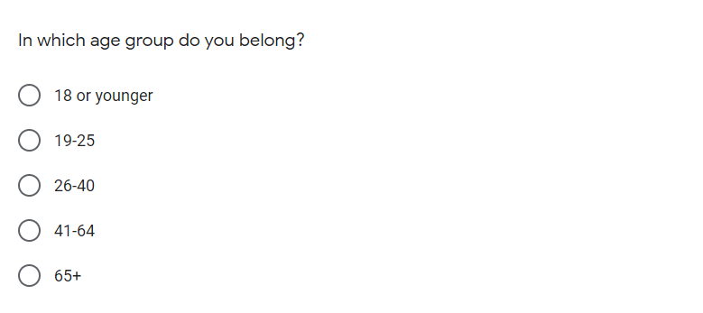

## Question 2.

With this question we want to determine whether the person has used a housing website before. That way we will know how many people have looked for a property themselves, or they have made other people look for them.

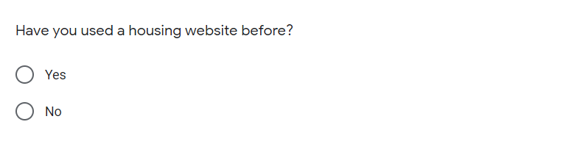

## Question 3.

With this question we want to see which website people use the most. That way we can check the most used ones and check if there are any flaws, interesting features, etc. In that website, which we can implement in our own.

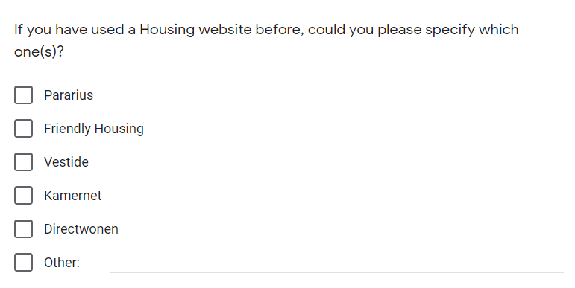

## Question 4.

With this question we can see how much time people have spent, using the accommodation websites.

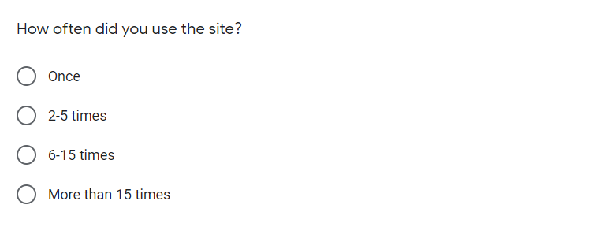

## Question 5.

With this question we want to determine whether the user uses desktop, tablet, mobile or other device to access the website. We use this question to see the 2 most used devices. So if the second most used one is mobile or tablet, we will make a port of the website for mobile devices or tablets.

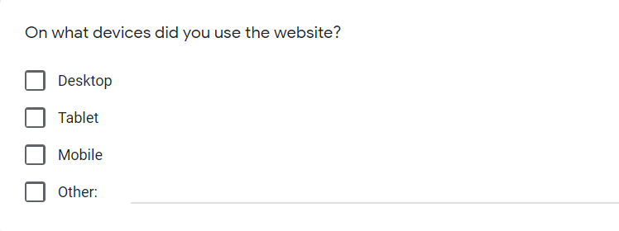

## Question 6.

With this question we want to see the two most used languages, so we can add it as a feature for our website. The page will originally be created in English, and in future we can add Dutch or German.

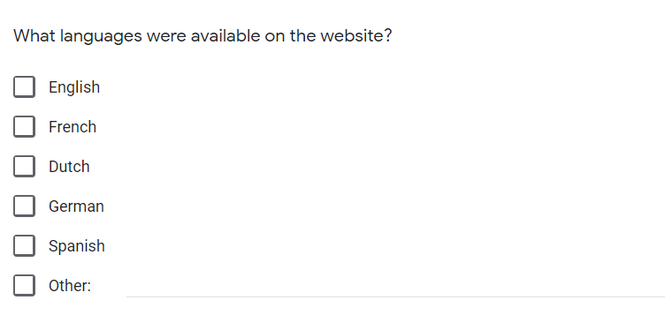

## Question 7.

With this question we would like to know If any person has used a feature that made their work easier. A feature that they enjoyed. So we could work on this feature and improve it and later add it to our website.

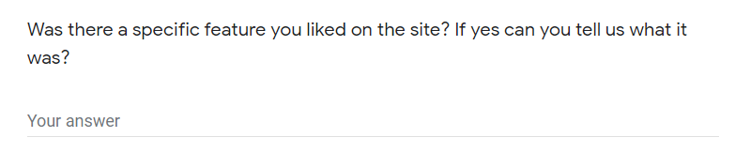

## Question 8, 9.

The following two questions are very important part of our research. With them we will be able to determine whether we should add subscription to our website or not. Many websites required subscriptions in order to use them and many times these subscriptions were useless. We could add subscriptions for other features but not for generally using the website.

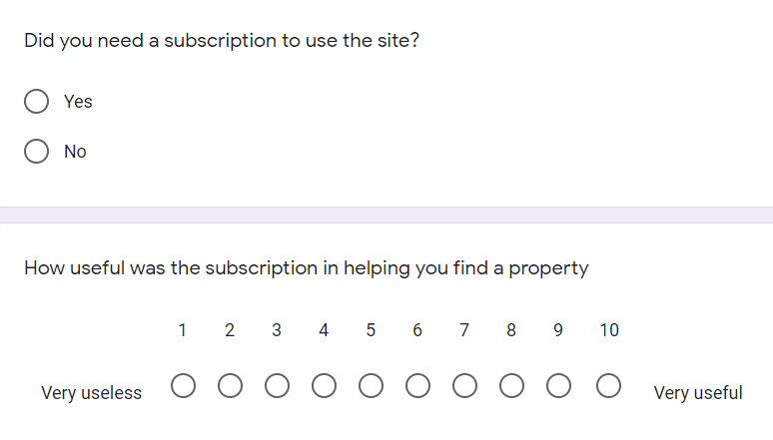

## Question 10.

With the following question we can determine what type the user is. A student looking for studio or room, or a family looking for a flat or a house. That way we can divide our listings for easier access to users of the website.

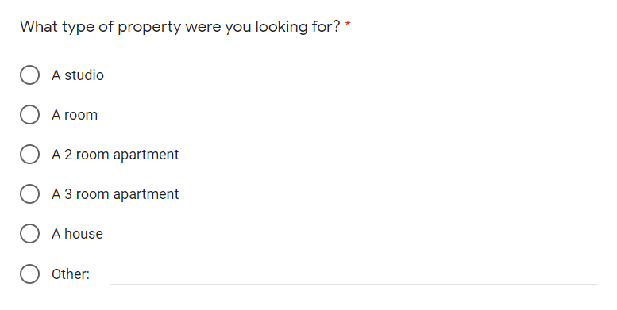

## Question 11.

With the following question we want to determine which features are the most important for people when looking for housing. That way we can later add the options as filters for our website. The answers we have here are taken from the 3 interviews we did for the survey. (see “transcript-interview-for-survey-Viktor.docx”, “transcript-interview-for-survey-Yavor.docx”, “transcript-interview-for-survey-Anne.docx”)

## Question 12.

With that question our team can determine on which price point of estates we should focus.

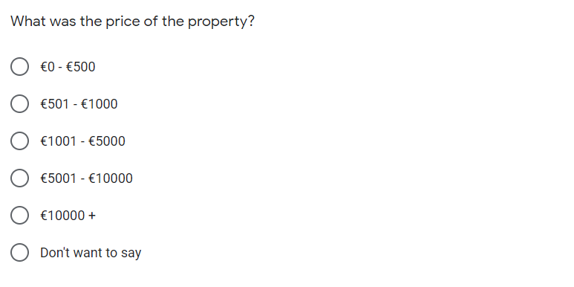

## Question 13.

Many people get scammed with fake pictures/photos of the listed estates. We want to see how many of our surveyed people have experienced this scam. We want to implement 360-degree photos in future in our website.

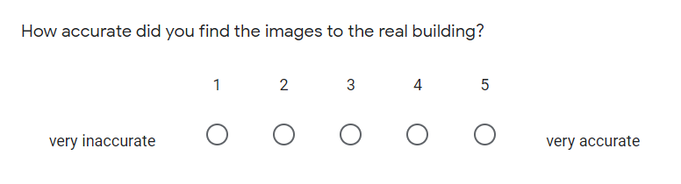

## Question 14.

Many housing agencies take quite a lot of time to respond when sent an email/question about a certain property. We want to see from our survey if this is true and if so, usually how many days does it take for people to get response. We would like to eliminate that drawback in our website.

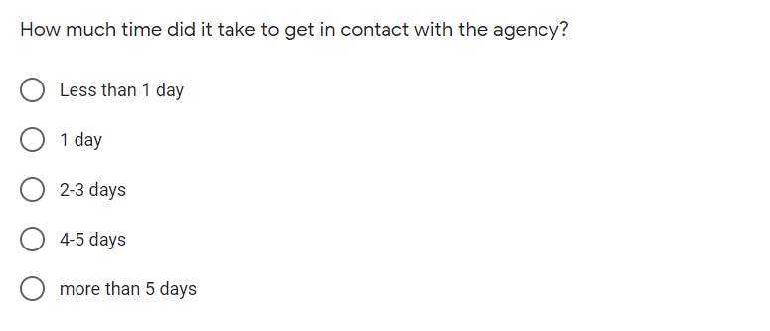

## Question 15.

Our last question is a follow-up to the previous one. Wanting to have a more clear view of the process of contacting the housing agencies.

